Prediction of Quantum Entanglement using Neural Network.

Introduction
Quantum computers are an entirely new way to do calculations. They use the strange rules of tiny objects' behaviour (quantum mechanics) to solve problems much faster than regular computers (Fan et al., 2003). Regular computers use bits, which can only be a zero or a one. Quantum computers use qubits, which can be both zero and one simultaneously (Fan et al., 2003). This allows them to explore many possibilities simultaneously, making them incredibly powerful.
One of the most essential ideas in quantum computing is "entanglement." This is where two qubits become "connected" together, even if they are far apart (Deng et al., 2017). It's like they instantly know what the other is doing. This strange connection is crucial for many quantum computing tasks (Deng et al., 2017). The degree of entanglement between two qubits can be measured using a quantity known as "concurrence" (Deng et al., 2017).
This project aimed to explore the intersection of quantum computing and classical machine learning. By focusing on the characterization of quantum entanglement through concurrence, it delved into the development of neural networks to predict this measure for two-qubit systems based on a given dataset. These efforts highlight how machine learning can contribute to solving complex problems in quantum science, paving the way for practical applications in quantum information and computation.

Literature
Machine learning has become an essential tool in quantum computing, especially for studying and predicting quantum entanglement. Ramezani et al. (2020) discuss how machine learning, including neural networks, can solve problems in quantum computing effectively. Deng et al. (2017) show that neural network models can represent and analyse quantum states, making them helpful in understanding quantum entanglement.
Feng and Chen (2024) explain how machine learning models can measure quantum entanglement, focusing on concurrence as a key measure. They demonstrate how these models can work accurately with quantum data. Fan et al. (2003) provide the theoretical background for concurrence, showing why it is essential for studying quantum entanglement. Together, These studies show how neural networks and machine learning can help better understand and predict quantum entanglement.

Variables
This section provides a detailed overview of the variables present in the dataset. The dataset comprises several variables capturing different aspects of the data. Each variable is described in terms of its name, description, and data type, identifying the response and predictor variables for analysis. Table 1 presents details about each variable, while Table 2 shows the nature of the variable and specifies whether they serve as a Response or Predictor variable.
Table 1: Variable names and their descriptions.
Variables | Descriptions
a1, a2 | Real and Imaginary part of the first component of the wave function
b1, b2 | Real and Imaginary part of the second component of the wave function
c1, c2 | Real and Imaginary part of the third component of the wave function
d1, d2 | Real and Imaginary part of the fourth component of the wave function
concurrence | The concurrence value, which quantifies the degree of quantum entanglement for the two-qubit system

Table 2: Nature of the variables.
Variables | Type of data | Response/ Predictor variable
a1, a2 | Float | Predictor
b1, b2 | Float | Predictor
c1, c2 | Float | Predictor
d1, d2 | Float | Predictor
concurrence | Float | Response

Basic Summary of the Data and Concurrence Distribution.
The dataset consists of nine variables, where a1, a2, b1, b2, c1, c2, d1, and d2 represent the predictor variables, and concurrence is the target variable of interest. A basic summary of the dataset is presented in the table below, showing descriptive statistics such as count, mean, standard deviation, minimum, and maximum values for each variable.

Table 3: Descriptive statistics.
 | a 1 | a 2 | b 1 | b 2 | c 1 | c 2 | d 1 | d 2 | Conc.
counts | 10000 | 10000 | 10000 | 10000 | 10000 | 10000 | 10000 | 10000 | 10000
mean | 0.0033 | -0.001 | -0.00 | 0.004 | 0.0003 | -0.01 | 0.003 | -0.002 | 0.592
Sd. | 0.3535 | 0.3510 | 0.351 | 0.355 | 0.3489 | 0.353 | 0.335 | 0.3544 | 0.229
min | -0.92721 | -0.919 | -0.92 | -0.95 | -0.935 | -0.91 | -0.95 | -0.961 | 0.013
1st Quantile | -0.25491 | -0.256 | -0.26 | -0.26 | -0.256 | -0.27 | -0.26 | -0.260 | 0.425
median | 0.00406 | -0.001 | -0.00 | 0.004 | -0.002 | -0.01 | 0.005 | -0.002 | 0.612
3rd Quantile | 0.26554 | 0.261 | 0.251 | 0.263 | 0.259 | 0.245 | 0.265 | 0.2588 | 0.778
Max | 0.97427 | 0.932768 | 0.964 | 0.943 | 0.9313 | 0.962 | 0.925 | 0.9410 | 0.999

To better understand the data, the distribution of the target variable “concurrence” is visualized alongside its training and testing subsets. The histograms in Figure 1 display the density of values, highlighting the spread and central tendency of concurrence across the dataset. These visualizations offer valuable insights into the characteristics of concurrence and ensure an appropriate data split for model training and evaluation.

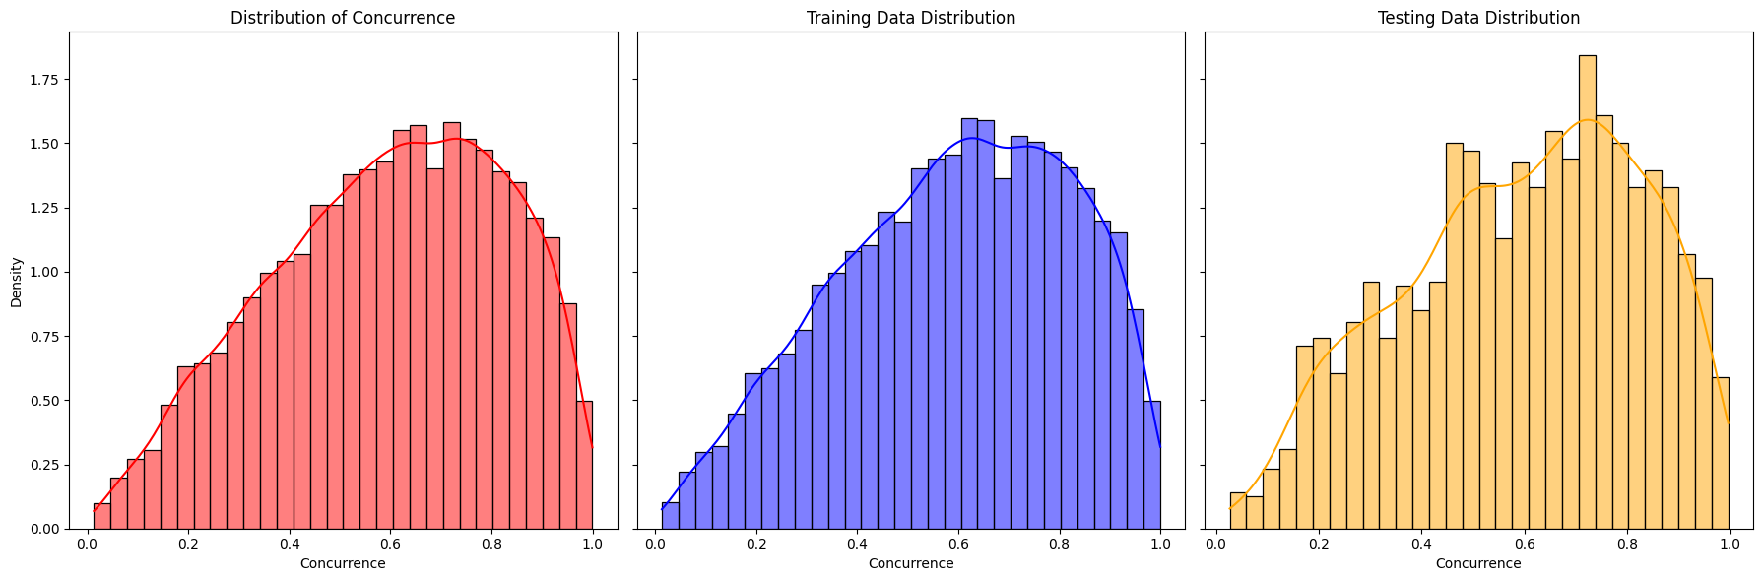

Figure 1: The spread and central tendency of concurrence across the dataset.
In Figure 1, the distributions of concurrence for the overall dataset, training data, and testing data all exhibit a slightly left-skewed pattern, with the majority of values concentrated between 0.4 and 0.8 and a peak around 0.6. The training data distribution closely mirrors the overall distribution, indicating that it is representative of the dataset as a whole. The testing data also follows a similar trend, though it appears slightly noisier with a marginally higher density around 0.2. These similarities suggest that the data split is balanced and preserves the key characteristics of the overall dataset, ensuring consistency in the concurrence values across the training and testing sets.

Model Selection and Processing
The dataset was already clean, with no missing values, duplicates, or outliers that needed correction or removal. The data is prepared for modelling.
Neural networks were chosen for this task because they are good at handling complex and non-linear relationships between inputs and outputs (Dongare et al., 2012). In this case, the variables describe different parts of a two-qubit quantum state and its entanglement properties. Predicting the concurrence, which measures how much the two qubits are entangled, involves understanding the complicated relationships between these variables.
The relationship between the inputs and the concurrence is not simple or linear. Neural networks are well-suited for such tasks because they have layers of neurons that can learn patterns and connections that simpler models, like linear regression, cannot (Dongare et al., 2012). Each layer in the network works on the data step by step, finding essential patterns that help make accurate predictions (Dongare et al. 2012).
Additionally, neural networks can handle high-dimensional data, such as in this task where there are multiple variables (real and imaginary parts, coefficients, and entanglement-related parameters) (Feng and Wu, 2018). They can learn how these variables interact to determine the concurrence by adjusting the network structure (like the number of layers and neurons) and using a loss function designed for regression; the model can provide reliable predictions (Feng and Wu, 2018).
Neural networks are also flexible and can be adapted to different kinds of data (Feng and Wu, 2018). This makes them a strong choice for modelling quantum systems, where the details are often complicated but need to be captured accurately to make good predictions (Feng and Wu, 2018).

The Model, Comprising Two Hidden Layers with 64 and 32 Neurons.

The artificial neural network (ANN) was developed to predict concurrence, a quantum entanglement measure based on input features representing components and parameters of a two-qubit quantum system. The model, comprising two hidden layers with 64 and 32 neurons, was trained over 50 epochs with a batch size of 32. Using the Adam optimizer and Mean Squared Error (MSE) as the loss function, the training process achieved a test loss (MSE) of 0.0127 and a test Mean Absolute Error (MAE) of 0.0892. The training and validation loss curves demonstrated consistent decreases over epochs, indicating effective learning without significant overfitting. The alignment of training and validation metrics further suggests that the model generalized well to unseen data.
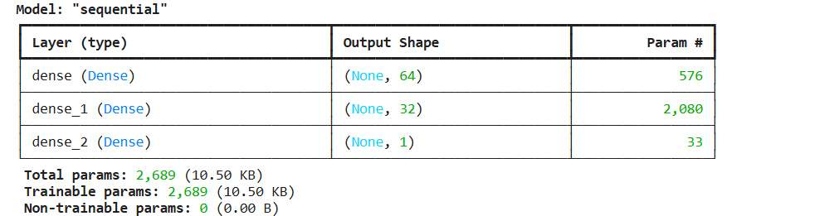
Figure 2: The model summary.
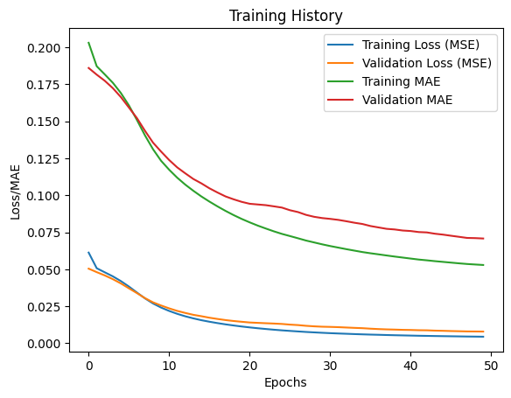
Figure 3: The training history for two hidden layers with 64 and 32 neurons.
Table 4: Results for two hidden layers with 64 and 32 neurons.
Test Loss (MSE) | 0.012659896165132523
Test MAE | 0.08924395591020584

The scatter plot comparing actual and predicted concurrence values confirms the model's accuracy, with most predictions closely following the ideal reference line. This indicates that the ANN effectively captured the underlying relationships between the input features and the target variable. The results highlight the neural network's ability to handle the non-linear and high-dimensional nature of the problem, providing reliable predictions of quantum entanglement. This approach could be extended or refined for more complex quantum systems or related applications.
.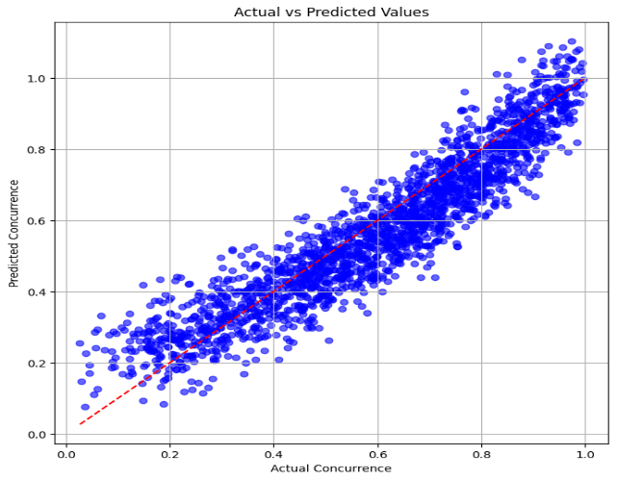
Figure 4: Scatter plot for the baseline model (for two hidden layers with 64 and 32 neurons).

The Model, Comprising Three Hidden Layers with 128, 64 and 32 Neurons.

The artificial neural network (ANN) was designed to predict concurrence, a measure of quantum entanglement, based on input variables representing the components and parameters of a two-qubit quantum state. This model included three hidden layers with 128, 64, and 32 neurons, each using the ReLU activation function. The Huber loss function, which is robust to outliers, was selected to handle potential irregularities in the data, and the Adam optimizer was employed to ensure efficient convergence. The model was trained for 50 epochs with a batch size of 32, achieving a low test loss of 0.00082 and a mean absolute error (MAE) of 0.0317, indicating high accuracy in predicting the concurrence.
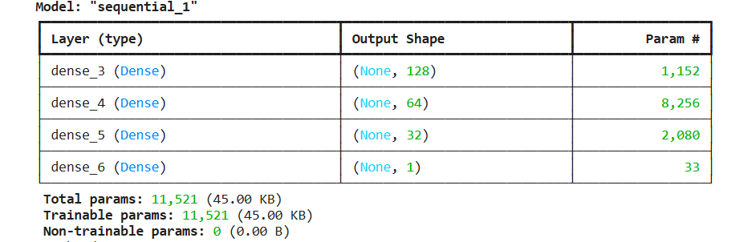
Figure 5: The model summary.
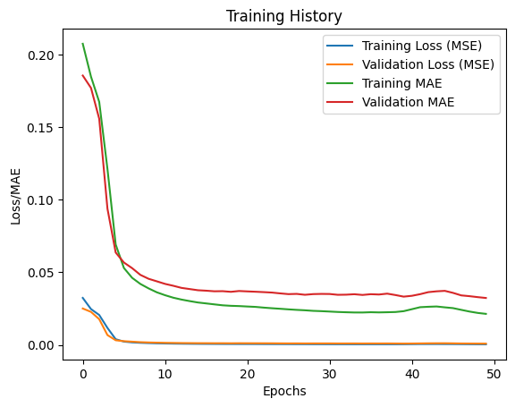
Figure 6: The training history for three hidden layers with 128, 64 and 32 neurons.

Table 5: Results for three hidden layers with 128, 64 and 32 neurons.
Test Loss (MSE) | 0.0008187428466044366
Test MAE | 0.03171329200267792

The training history showed a consistent decline in training and validation loss, demonstrating effective learning and minimal risk of overfitting. The scatter plot of actual versus predicted concurrence values revealed a strong correlation, with most points clustering closely around the ideal reference line. This highlights the ANN’s ability to capture the complex relationships between input variables and concurrence. The results validate the suitability of neural networks for modelling non-linear quantum systems and suggest this approach can be further applied to other quantum mechanics problems requiring accurate predictions of entanglement properties.
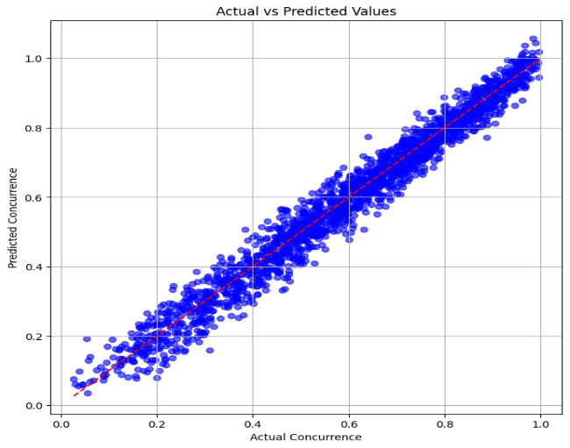
Figure 7: Scatter plot for the three hidden layers with 128, 64 and 32 neurons.

Comparing two hidden layers versus three hidden layers

The improved ANN model (three hidden layers with 128, 64, and 32 neurons) for predicting concurrence in two-qubit quantum systems showed much better accuracy than the baseline model (two hidden layers with 64 and 32 neurons). The main changes included adding three hidden layers, using the ReLU activation function, and applying the Huber loss function. These updates helped the model handle complex patterns, train more efficiently, and deal better with noise or outliers in the data. The final model had a much lower test loss and mean absolute error, showing it accurately predicted concurrence. This success shows how well-designed ANN models and the right choice of activation and loss functions can effectively model quantum systems.

Concussion
This project showed how artificial neural networks (ANNs) can predict quantum entanglement, measured by concurrence, in two-qubit quantum systems. Using a clean dataset and well-designed models, we demonstrated that ANNs can learn the complex and non-linear relationships involved in quantum systems.
The basic model with two hidden layers gave good results, but the improved model with three hidden layers performed much better. The deeper model, along with the ReLU activation function and Huber loss function, helped capture complex patterns and handle noise in the data. It achieved a lower test loss and mean absolute error, showing its high accuracy in predicting concurrence.
This project highlights that neural networks are a powerful tool for studying quantum systems. It also shows the importance of choosing the right model design, activation, and loss functions. These results guide future work using machine learning to study and predict quantum entanglement in more advanced systems.

References

Ramezani, Somayeh Bakhtiari, et al. "Machine learning algorithms in quantum computing: A survey." 2020 International joint conference on neural networks (IJCNN). IEEE, 2020.
Deng, Dong-Ling, Xiaopeng Li, and S. Das Sarma. "Quantum entanglement in neural network states." Physical Review X 7.2 (2017): 021021.
Feng, Changchun, and Lin Chen. "Quantifying quantum entanglement via machine learning models." Communications in Theoretical Physics 76.7 (2024): 075104.
Fan, Heng, Keiji Matsumoto, and Hiroshi Imai. "Quantify entanglement by concurrence hierarchy." Journal of Physics A: Mathematical and General 36.14 (2003): 4151.
Dongare, A. D., R. R. Kharde, and Amit D. Kachare. "Introduction to artificial neural network." International Journal of Engineering and Innovative Technology (IJEIT) 2.1 (2012): 189-194.
Wu, Yu-chen, and Jun-wen Feng. "Development and application of artificial neural network." Wireless Personal Communications 102 (2018): 1645-1656.

